|  |
| --- |
| Close-up image showing the leaf-sides of two oversized books side-by-side on a bookshelf, with additional books in soft focus background |
| PLSQL Project  Advanced Databases |
| |  |  |  | | --- | --- | --- | | Reonne Benoy-A00268832 | 5/14/20 | Athlone Institute of Technology | |

Contents

Question 1 1

Question 2 4

Question 3 7

Question 4 10

Stage 1 10

Stage 2 13

Stage 3 17

PLSQL Project

# Question 1

Clear Screen

Set Serveroutput on Size 100000

Drop Table Concert_Capacity_Tracker;

Create Table Concert_Capacity_Tracker(Concert_Id Number(3), Group_Name Varchar2(15), Increase Number(3), Description Varchar2(50), User_Name Varchar2(10), Exec_Date Date);

Create or Replace Procedure Raise_Concert_Capacity(Conc_Id In Integer, Increase In Integer) Is

V_Group_Name Concert.Group_Name%Type;

V_Category Concert.Category%Type;

V_Capacity Concert.Capacity%Type;

V_Actual_Attendance Concert.Actual_Attendance%Type;

V_Ticket_Price Concert.Ticket_Price%Type;

T_Price_Missing Exception;

Illegal_Category Exception;

Increase_Too_Low Exception;

/*Reonne Benoy-A00268832*/

Begin

Dbms_Output.Put_Line('View Data Before Update');

Select Group_Name, Category, Capacity, Actual_Attendance, Ticket_Price Into V_Group_Name, V_Category, V_Capacity, V_Actual_Attendance, V_Ticket_Price

From Concert

Where Concert.Concert_Id = Conc_Id;

Dbms_Output.Put_Line('Group_Name:'|| V_Group_Name||'Original Capacity:'||V_Capacity);

If V_Ticket_Price Is Null Then

Raise T_Price_Missing;

Elsif Increase<=500 Then

Raise Increase_Too_Low;

Elsif V_Category Not In ('ROCK','CLASSICAL') Then

Raise Illegal_Category;

Else

Update Concert

Set Capacity = Capacity + Increase

Where Concert.Concert_Id = Conc_Id;

End If;

Dbms_Output.Put_Line('Output After Update');

Select Group_Name,Capacity Into V_Group_Name, V_Capacity

From Concert

Where Concert.Concert_Id = Conc_Id;

Dbms_Output.Put_Line('Group Name:' || V_Group_Name|| 'Updated Capacity:'||V_Capacity);

Exception

When T_Price_Missing Then

Insert Into Concert_Capacity_Tracker Values(Conc_Id,V_Group_Name,Increase,'Ticker Price is Missing',User,Sysdate);

When Illegal_Category Then

Insert Into Concert_Capacity_Tracker Values(Conc_Id,V_Group_Name,Increase,'No Concert Category as such', User, Sysdate);

When Increase_Too_Low Then

Insert Into Concert_Capacity_Tracker Values(Conc_Id,V_Group_Name,Increase,'Increase Capacity is low', User, Sysdate);

End Raise_Concert_Capacity;

/

Sho Err

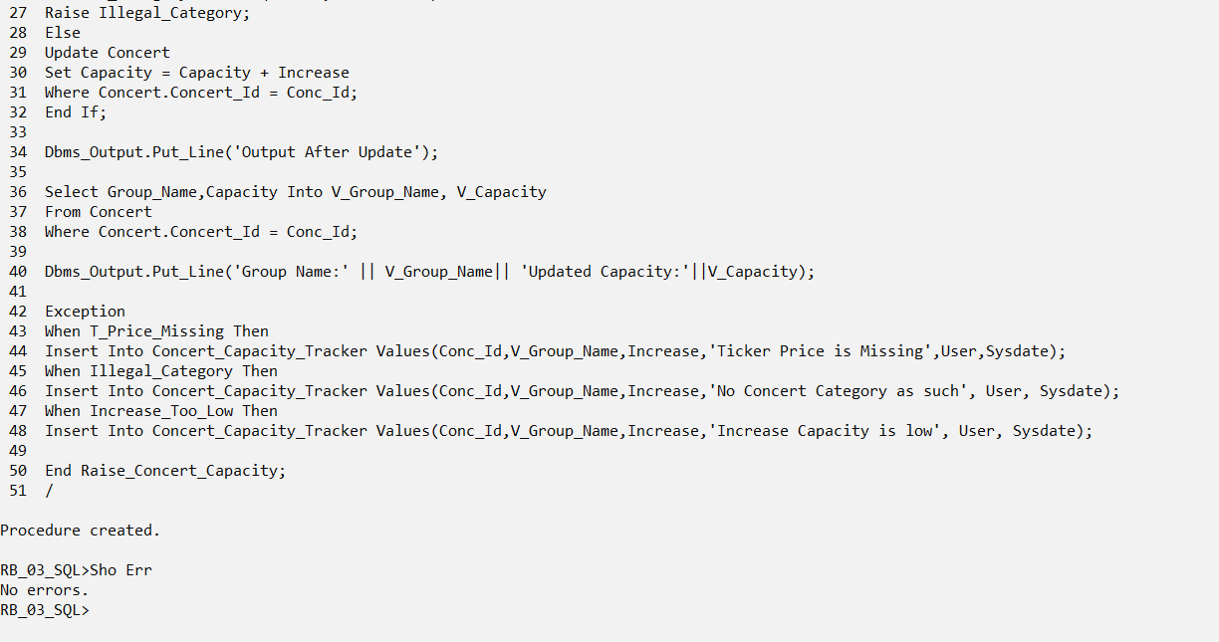

Execute Raise_Concert_Capacity(171,600);

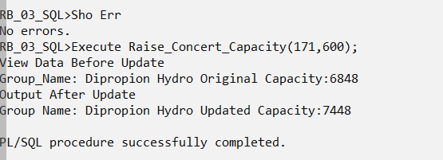

Execute Raise_Concert_Capacity(544,700);

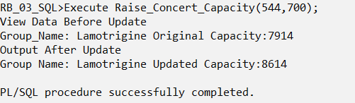

Execute Raise_Concert_Capacity(171,400);

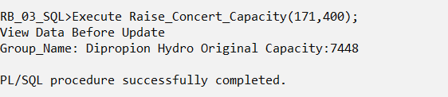

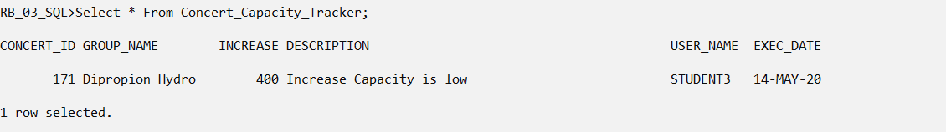

Insert Into Concert(Concert_Id,Group_Name,Category,Ticket_Price) Values (777,'Quary','Rock',Null);

Execute Raise_Concert_Capacity(777,600);

Insert Into Concert(Concert_Id,Group_Name,Category,Ticket_Price) Values (999,'Bond','Athem',40.05);

Execute Raise_Concert_Capacity(999,700);

Rollback;

# Question 2

Clear Screen

Set Serveroutput on Size 1000000

Set Linesize 180

Drop Table DML_Journalist_log;

Create Table DML_Journalist_log(Username Varchar2(15), Exec_Date Date, Rows_Changed Number(3));

Create Or Replace Procedure Modify_LowEarnings_Journ As

Cursor Journalist_Cur Is Select Journalist_Id, Forename, Surname, Annual_Earnings

From Journalist

Order By Annual_Earnings

For Update Of Annual_Earnings;

V_Journalist_Rec Journalist_Cur%Rowtype;

V_Total_Earnings_Bottom5 Number(9,2):=0;

V_Num_Journalist_Changed Number(3):=0;

/*Reonne Benoy-A00268832*/

Begin

Open Journalist_Cur;

Dbms_Output.Put_Line('List of 5 Journalists with the lowest annual earnings');

For V_Count In 1..5

Loop

Fetch Journalist_Cur Into V_Journalist_Rec;

Exit When Journalist_Cur%Notfound;

Dbms_Output.Put_Line('Journalist ID: '||V_Journalist_Rec.Journalist_Id);

Dbms_Output.Put_Line('Name: '|| V_Journalist_Rec.Forename|| ' '|| V_Journalist_Rec.Surname);

Dbms_Output.Put_Line('Annual_Earnings: '|| V_Journalist_Rec.Annual_Earnings);

Dbms_Output.Put_Line('****************************************************************************');

V_Total_Earnings_Bottom5:=V_Total_Earnings_Bottom5 + V_Journalist_Rec.Annual_Earnings;

Update Journalist

Set Annual_Earnings = Annual_Earnings + 2000

Where Current Of Journalist_Cur;

V_Num_Journalist_Changed := V_Num_Journalist_Changed + 1;

End Loop;

Close Journalist_Cur;

Dbms_Output.Put_Line('The Total annual earnings of the bottom 5 journalists: '||V_Total_Earnings_Bottom5);

Insert Into DML_Journalist_log Values(User,Sysdate,V_Num_Journalist_Changed);

End;

/

Sho Err

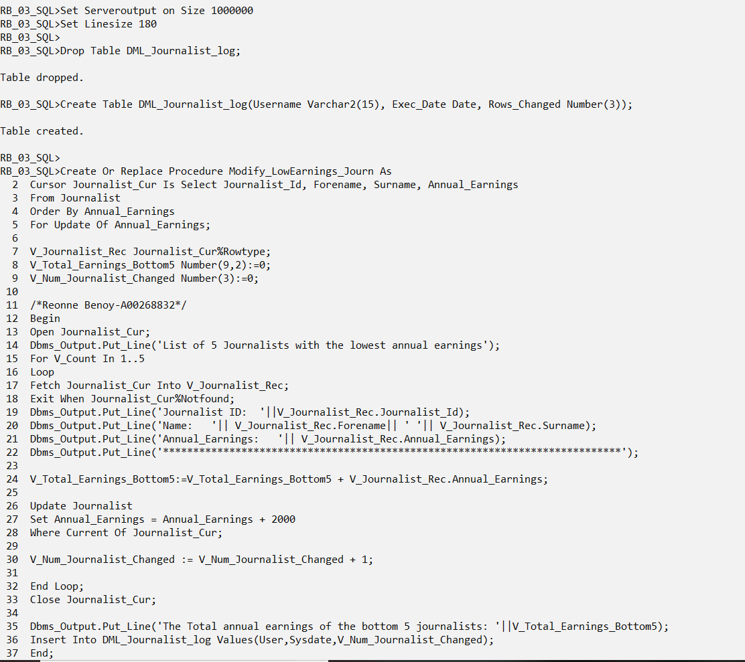

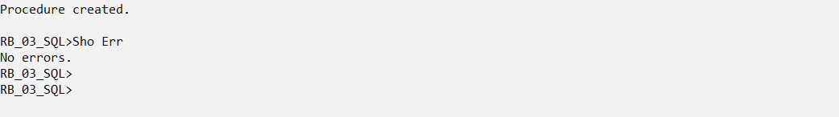

Select Sum(Annual_Earnings)

From Journalist;

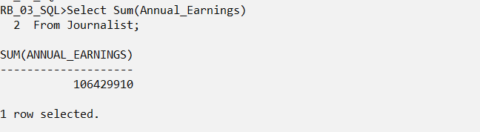

Execute Modify_LowEarnings_Journ;

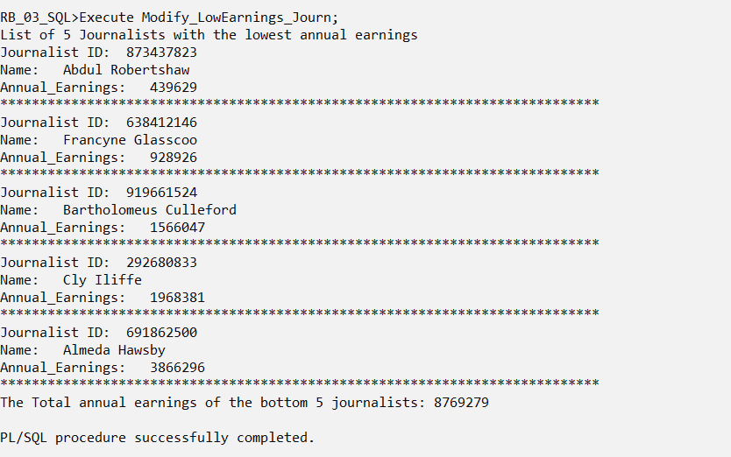

Select Sum(Annual_Earnings)

From Journalist;

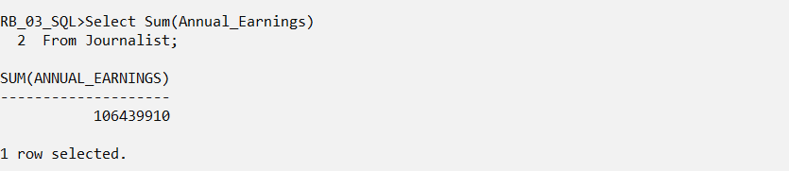

Select * From DML_Journalist_log;

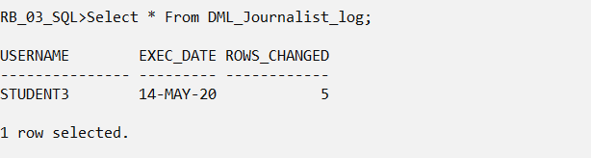

Rollback;

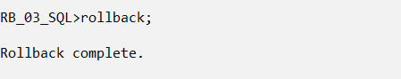

# Question 3

Clear Screen

Set Serveroutput On Size 1000000

Drop Table Deleted_Newspaper_Log;

Create Table Deleted_Newspaper_Log(NewspaperID Number(8), Username Varchar2(15),Exec_Date Date);

Create Or Replace Procedure Remove_Newspaper As

Cursor Newspaper_Cur Is Select Newspaper_Id, Name, Annual_Turnover

From Newspaper

Order By Name

For Update;

V_Newspaper_Rec Newspaper_Cur%Rowtype;

V_Count_Journalists Number(2):=0;

V_Count_Turnover_Increase Number(2):=0;

V_Count_Deleted_Newspapers Number(2):=0;

/*Reonne Benoy-A00268832*/

Begin

Dbms_Output.Put_Line('List of all the Newspaper companies ordered by their names');

Open Newspaper_Cur;

Loop

Fetch Newspaper_Cur Into V_Newspaper_Rec;

Exit When Newspaper_Cur%Notfound;

Select NVL(Count(*),0) Into V_Count_Journalists

From Journalist, Newspaper

Where Journalist.Newspaper_Id = Newspaper.Newspaper_Id;

Dbms_Output.Put_Line('Name: '|| V_Newspaper_Rec.Name|| 'Annual Turnover:' || V_Newspaper_Rec.Annual_Turnover);

Dbms_Output.Put_Line('Number of Journalists employed:' || V_Count_Journalists);

If V_Count_Journalists = 0 Then

Dbms_Output.Put_Line('Newspaper Comapany '|| V_Newspaper_Rec.Name||' will be deleted');

Delete

From Newspaper

Where Current Of Newspaper_Cur;

V_Count_Deleted_Newspapers:= V_Count_Deleted_Newspapers + 1;

Else

Dbms_Output.Put_Line('Newspaper Company '|| V_Newspaper_Rec.Name||' will get a Turnover increase');

Update Newspaper

Set Annual_Turnover = Annual_Turnover + 15000

Where Current Of Newspaper_Cur;

V_Count_Turnover_Increase:=V_Count_Turnover_Increase + 1;

End If;

Dbms_Output.Put_Line('***************************************************************');

Insert Into Deleted_Newspaper_Log Values(V_Newspaper_Rec.Newspaper_Id,User,Sysdate);

End Loop;

Close Newspaper_Cur;

Dbms_Output.Put_Line('Number of Newspapers that have been removed: '|| V_Count_Deleted_Newspapers);

Dbms_Output.Put_Line('Number of Newspapers that got an Annual Turnover Increase: '|| V_Count_Turnover_Increase);

End;

/

Sho Err

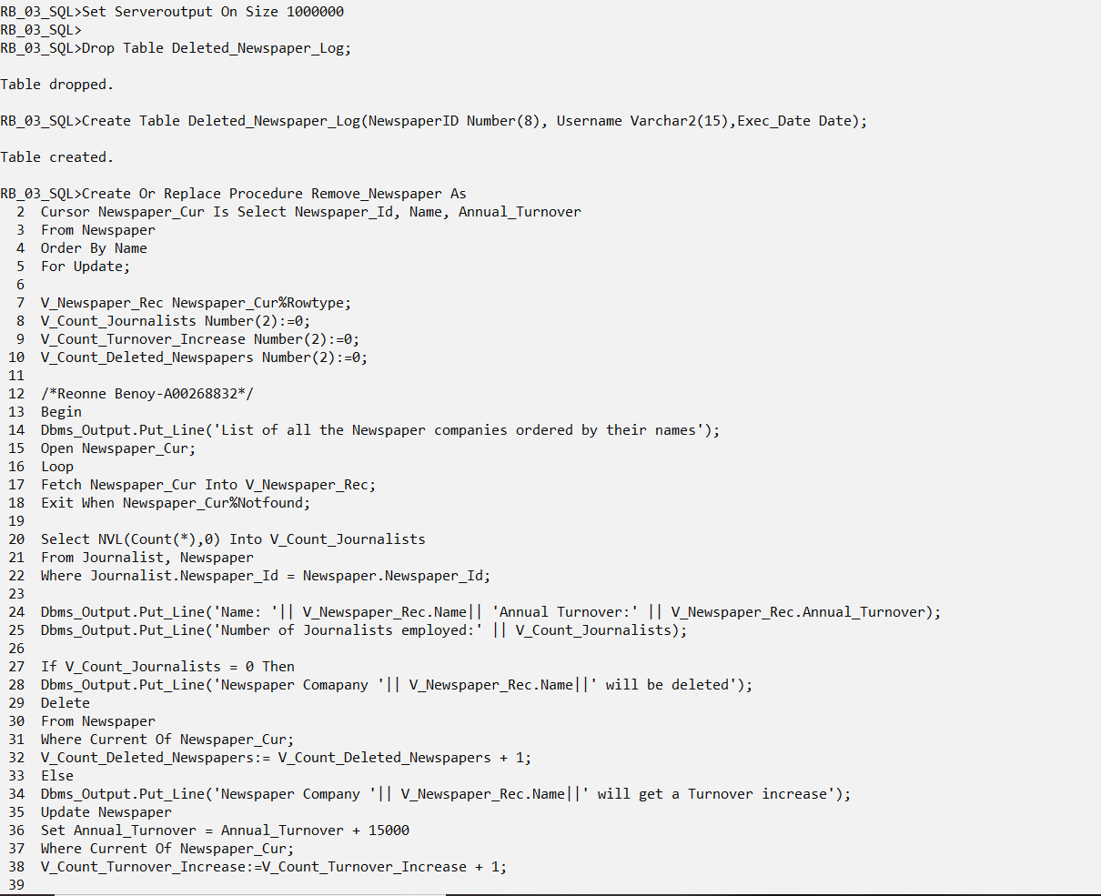

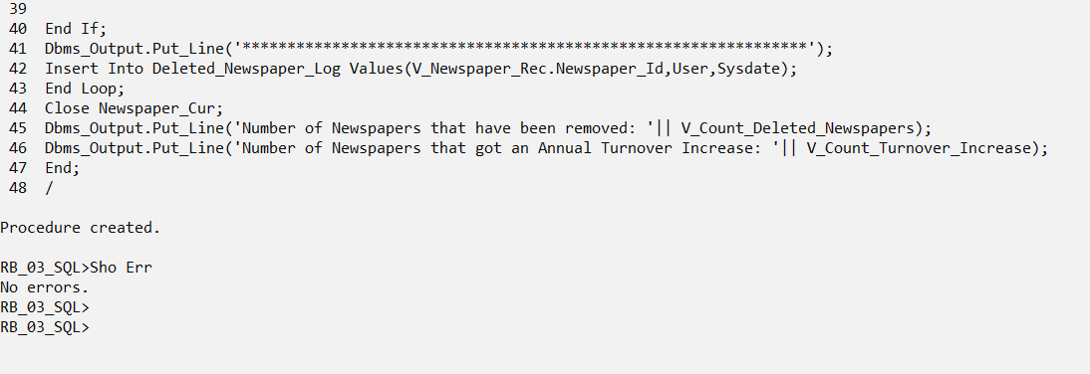

Execute Remove_Newspaper;

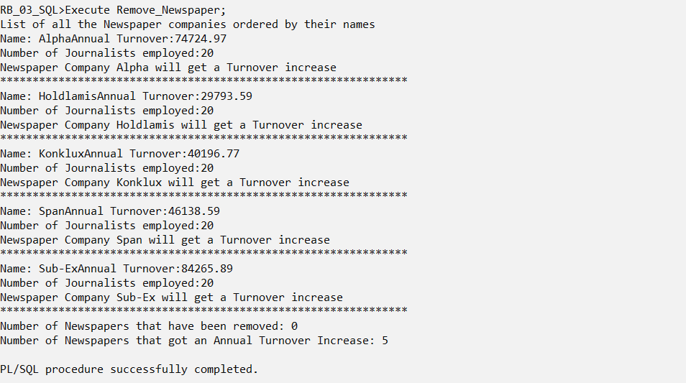

Select * From Deleted_Newspaper_Log;

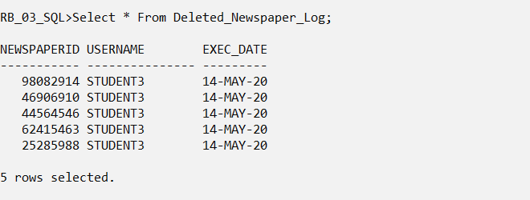

# Question 4

## Stage 1

Clear Screen

Set Serveroutput On Size 1000000

Create Or Replace Procedure Venue_Manage(VenueId In Number, Cap_Prop_Increase In Number) Is

V_Name Venue.Name%Type;

V_City Venue.City%Type;

V_Category Venue.Category%Type;

V_Cost Venue.Cost%Type;

V_Capacity Venue.Capacity%Type;

V_Actual_Inc Number(4);

V_Max_Cap Venue.Capacity%Type;

V_Min_Cap Venue.Capacity%Type;

V_Avg_Cap Venue.Capacity%Type;

V_Max_Cap_Cat Venue.Capacity%Type;

V_Min_Cap_Cat Venue.Capacity%Type;

V_Avg_Cap_Cat Venue.Capacity%Type;

/*Reonne Benoy-A00268832*/

Begin

Dbms_Output.Put_Line('Display Venue details');

Select Name,City,Category,Cost,Capacity Into V_Name,V_City,V_Category,V_Cost,V_Capacity

From Venue

Where Venue.Venue_Id = VenueId;

Dbms_Output.Put_Line('Details for '||VenueId||' Name: ' || V_Name);

Dbms_Output.Put_Line('City:' || V_City|| ' Category:' || V_Category|| ' Capacity:'||V_Capacity||'Cost:'|| V_Cost);

Dbms_Output.Put_Line('******************************************************************************');

Dbms_Output.Put_Line('Original Overall Capacity');

Select Max(Capacity),Min(Capacity),Avg(Capacity) Into V_Max_Cap,V_Min_Cap, V_Avg_Cap

From Venue;

Dbms_Output.Put_Line('Max Capacity: ' || V_Max_Cap|| ' Min Capacity: '|| V_Min_Cap || ' Avg Capacity: '||V_Avg_Cap);

Dbms_Output.Put_Line('******************************************************************************************');

Dbms_Output.Put_Line('Original Capacity');

Select Max(Capacity),Min(Capacity),Avg(Capacity) Into V_Max_Cap_Cat, V_Min_Cap_Cat, V_Avg_Cap_Cat

From Venue

Where Venue.Category = V_Category;

Dbms_Output.Put_Line('Max Category Capacity: '|| V_Max_Cap_Cat|| ' Min Category Capacity: '|| V_Min_Cap_Cat|| ' Avg Category Capacity: '||V_Avg_Cap_Cat);

Dbms_Output.Put_Line('***************************************************************************************');

If V_Capacity>V_Avg_Cap And V_Capacity<V_Max_Cap Then

V_Actual_Inc:= Cap_Prop_Increase;

Elsif V_Capacity<V_Avg_Cap And V_Capacity>V_Min_Cap Then

V_Actual_Inc:= Cap_Prop_Increase*1.50;

Else

V_Actual_Inc:= Cap_Prop_Increase*0.90;

End If;

Dbms_Output.Put_Line('Actual Increase of Capacity: ' || V_Actual_Inc);

Update Venue

Set Capacity=Capacity + V_Actual_Inc

Where Venue.Venue_Id = VenueId;

Dbms_Output.Put_Line('Details for '||VenueId||' Name: '|| V_Name);

Dbms_Output.Put_Line('City:' || V_City|| ' Category:' || V_Category|| ' Capacity:'||V_Capacity||'Cost:'|| V_Cost);

Dbms_Output.Put_Line('Overall Capacity After Increase');

Select Max(Capacity),Min(Capacity),Avg(Capacity) Into V_Max_Cap,V_Min_Cap, V_Avg_Cap

From Venue;

Dbms_Output.Put_Line('Max Capacity: ' || V_Max_Cap|| ' Min Capacity: '|| V_Min_Cap || ' Avg Capacity: '||V_Avg_Cap);

Dbms_Output.Put_Line('******************************************************************************************');

Dbms_Output.Put_Line('Overall Capacity by Categories After Increase');

Select Max(Capacity),Min(Capacity),Avg(Capacity) Into V_Max_Cap_Cat, V_Min_Cap_Cat, V_Avg_Cap_Cat

From Venue

Where Venue.Category = V_Category;

Dbms_Output.Put_Line('Max Category Capacity: '|| V_Max_Cap_Cat|| ' Min Category Capacity: '|| V_Min_Cap_Cat|| ' Avg Category Capacity: '||V_Avg_Cap_Cat);

End;

/

Sho Err

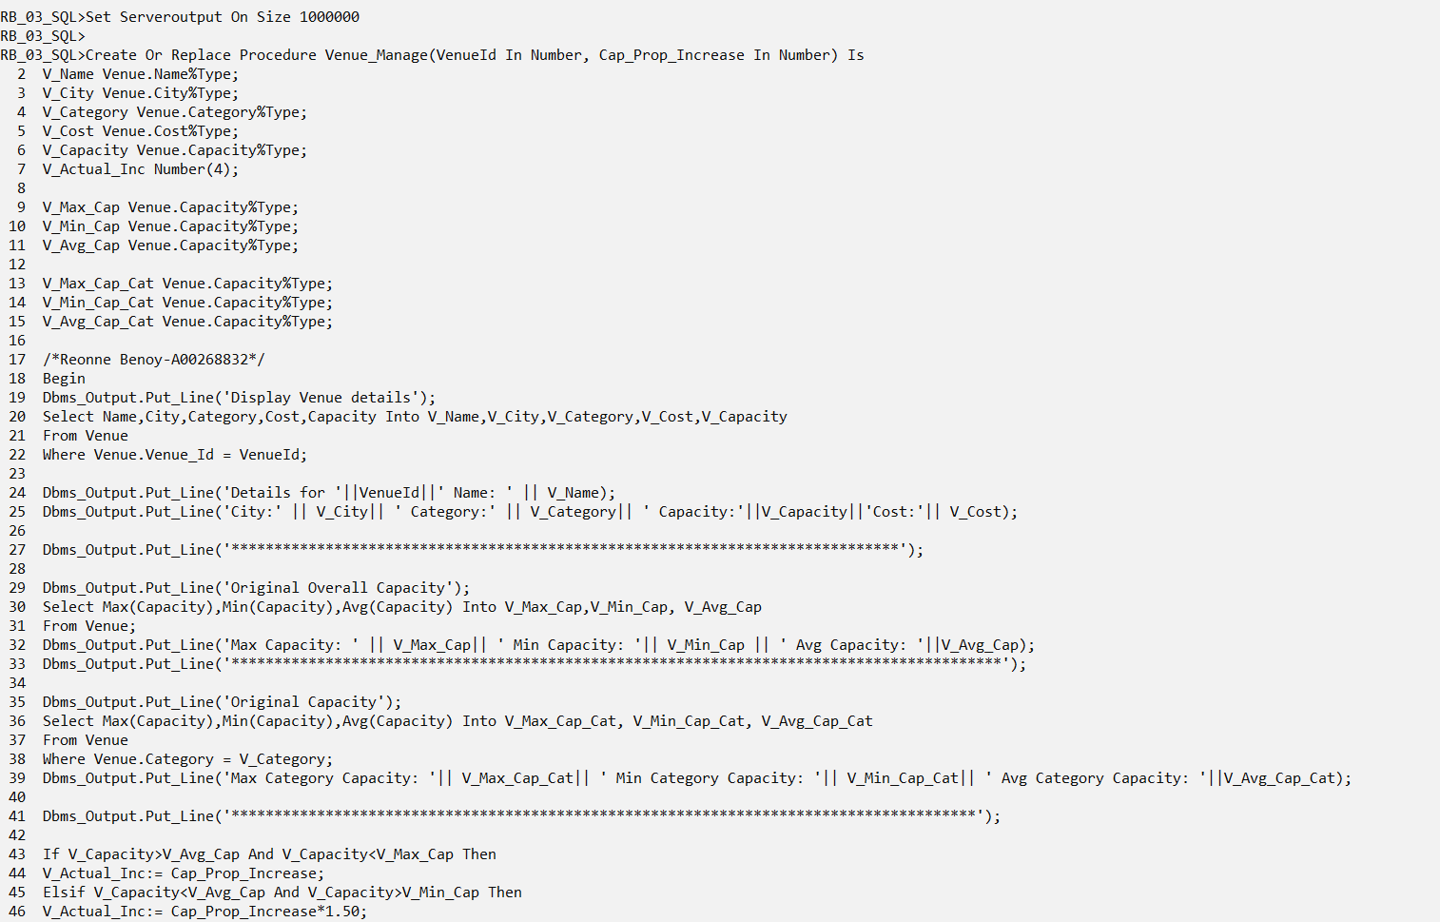

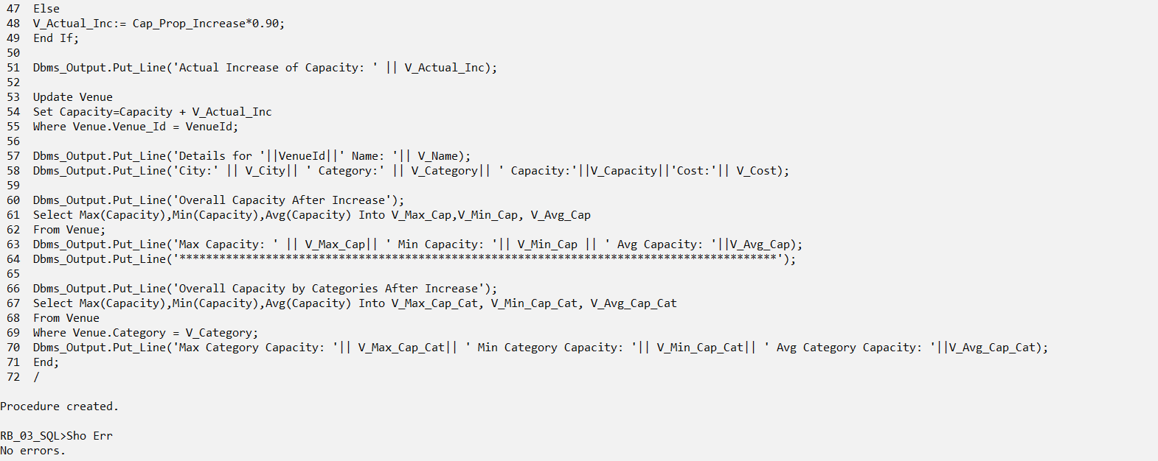

Execute Venue_Manage(4,1000);

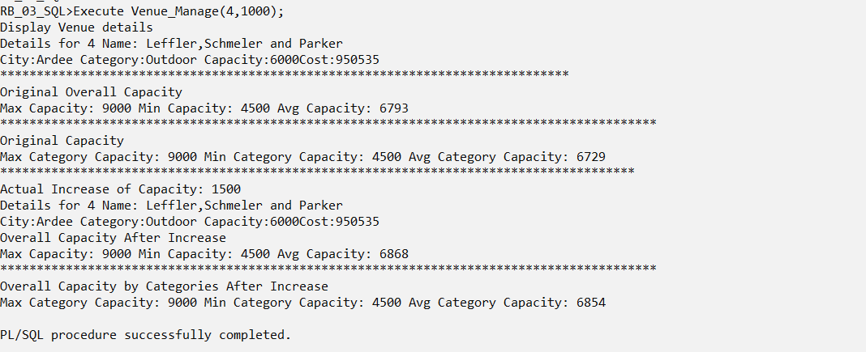

Rollback;

## Stage 2

**Stored Procedures and Functions**

Clear Screen

Set Serveroutput On Size 1000000

Create Or Replace Procedure Get_Venue_Details(VenueId In Number, V_Name Out Varchar, V_City Out Varchar, V_Category Out Varchar, V_Capacity Out Number, V_Cost Out Number) As

Begin

Select Name,City,Category,Cost,Capacity Into V_Name,V_City,V_Category,V_Cost,V_Capacity

From Venue

Where Venue.Venue_Id = VenueId;

End Get_Venue_Details;

/

Sho Err

Create Or Replace Procedure Calc_Overall_Capacity(V_Max_Cap Out Number, V_Min_Cap Out Number, V_Avg_Cap Out Number) As

Begin

Select Max(Capacity),Min(Capacity),Avg(Capacity) Into V_Max_Cap,V_Min_Cap, V_Avg_Cap

From Venue;

End Calc_Overall_Capacity;

/

Sho Err

Create Or Replace Procedure Calc_Category_Capacity(V_Category In Varchar, V_Max_Cap_Cat Out Number, V_Min_Cap_Cat Out Number, V_Avg_Cap_Cat Out Number) As

Begin

Select Max(Capacity),Min(Capacity),Avg(Capacity) Into V_Max_Cap_Cat, V_Min_Cap_Cat, V_Avg_Cap_Cat

From Venue

Where Venue.Category = V_Category;

End Calc_Category_Capacity;

/

Sho Err

Create Or Replace Procedure Modify_Capacity(VenueId In Number, V_Actual_Inc In Number) As

Begin

Update Venue

Set Capacity=Capacity + V_Actual_Inc

Where Venue.Venue_Id = VenueId;

End Modify_Capacity;

/

Sho Err

Create Or Replace Function Updated_Capacity(VenueId In NUMBER) Return Number Is

V_Updated_Capacity Venue.Capacity%Type;

Begin

Select Capacity Into V_Updated_Capacity

From Venue

Where Venue.Venue_Id = VenueId;

Return V_Updated_Capacity;

End Updated_Capacity;

/

Sho Err

Create Or Replace Procedure Venue_Manage(VenueId In Number, Cap_Prop_Increase In Number) Is

V_Name Venue.Name%Type;

V_City Venue.City%Type;

V_Category Venue.Category%Type;

V_Cost Venue.Cost%Type;

V_Capacity Venue.Capacity%Type;

V_Actual_Inc Number(4);

V_New_Capacity Venue.Capacity%Type;

V_Max_Cap Venue.Capacity%Type;

V_Min_Cap Venue.Capacity%Type;

V_Avg_Cap Venue.Capacity%Type;

V_Max_Cap_Cat Venue.Capacity%Type;

V_Min_Cap_Cat Venue.Capacity%Type;

V_Avg_Cap_Cat Venue.Capacity%Type;

/*Reonne Benoy-A00268832*/

Begin

Dbms_Output.Put_Line('Display Venue details');

Get_Venue_Details(VenueId, V_Name, V_City, V_Category, V_Capacity, V_Cost);

Dbms_Output.Put_Line('Details for '||VenueId||' Name: ' || V_Name);

Dbms_Output.Put_Line('City:' || V_City|| ' Category:' || V_Category|| ' Capacity:'||V_Capacity||'Cost:'|| V_Cost);

Dbms_Output.Put_Line('******************************************************************************');

Dbms_Output.Put_Line('Original Overall Capacity');

Calc_Overall_Capacity(V_Max_Cap, V_Min_Cap, V_Avg_Cap);

Dbms_Output.Put_Line('Max Capacity: ' || V_Max_Cap|| ' Min Capacity: '|| V_Min_Cap || ' Avg Capacity: '||V_Avg_Cap);

Dbms_Output.Put_Line('******************************************************************************************');

Dbms_Output.Put_Line('Original Capacity');

Calc_Category_Capacity(V_Category,V_Max_Cap_Cat,V_Min_Cap_Cat,V_Avg_Cap_Cat);

Dbms_Output.Put_Line('Max Category Capacity: '|| V_Max_Cap_Cat|| ' Min Category Capacity: '|| V_Min_Cap_Cat|| ' Avg Category Capacity: '||V_Avg_Cap_Cat);

Dbms_Output.Put_Line('***************************************************************************************');

If V_Capacity>V_Avg_Cap And V_Capacity<V_Max_Cap Then

V_Actual_Inc:= Cap_Prop_Increase;

Elsif V_Capacity<V_Avg_Cap And V_Capacity>V_Min_Cap Then

V_Actual_Inc:= Cap_Prop_Increase*1.50;

Else

V_Actual_Inc:= Cap_Prop_Increase*0.90;

End If;

Dbms_Output.Put_Line('Actual Increase of Capacity: ' || V_Actual_Inc);

Modify_Capacity(VenueId, V_Actual_Inc);

V_New_Capacity:= Updated_Capacity(VenueId);

Dbms_Output.Put_Line('Updated Capacity: ' || V_New_Capacity);

Get_Venue_Details(VenueId, V_Name, V_City, V_Category, V_Capacity, V_Cost);

Dbms_Output.Put_Line('Details for '||VenueId||' Name: '|| V_Name);

Dbms_Output.Put_Line('City:' || V_City|| ' Category:' || V_Category|| ' Capacity:'||V_Capacity||'Cost:'|| V_Cost);

Dbms_Output.Put_Line('Overall Capacity After Increase');

Calc_Overall_Capacity(V_Max_Cap, V_Min_Cap, V_Avg_Cap);

Dbms_Output.Put_Line('Max Capacity: ' || V_Max_Cap|| ' Min Capacity: '|| V_Min_Cap || ' Avg Capacity: '||V_Avg_Cap);

Dbms_Output.Put_Line('******************************************************************************************');

Dbms_Output.Put_Line('Overall Capacity by Categories After Increase');

Calc_Category_Capacity(V_Category,V_Max_Cap_Cat,V_Min_Cap_Cat,V_Avg_Cap_Cat);

Dbms_Output.Put_Line('Max Category Capacity: '|| V_Max_Cap_Cat|| ' Min Category Capacity: '|| V_Min_Cap_Cat|| ' Avg Category Capacity: '||V_Avg_Cap_Cat);

End Venue_Manage;

/

Sho Err

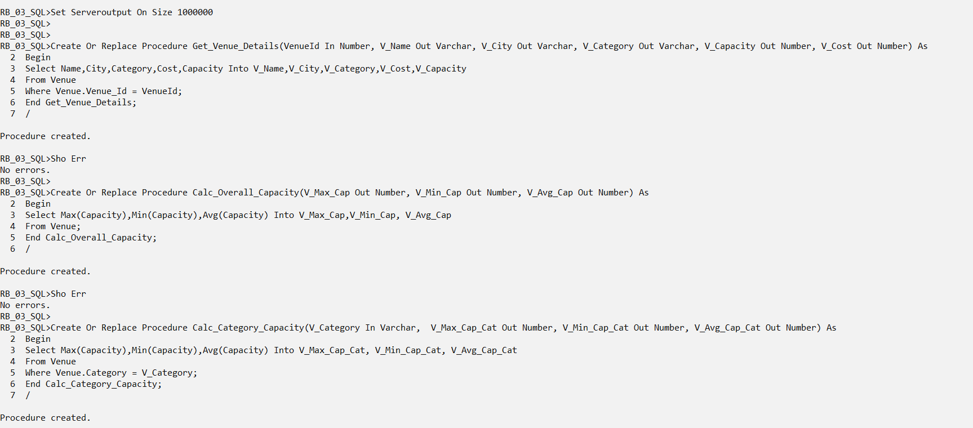

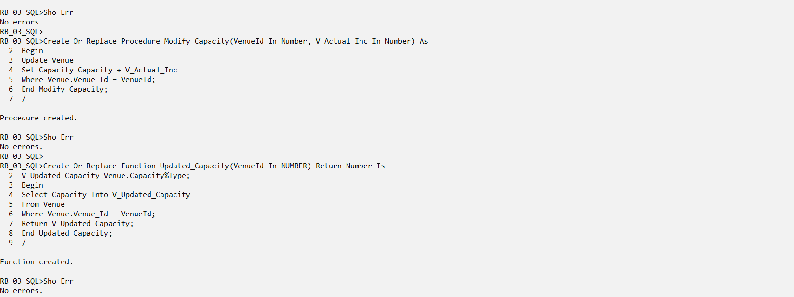

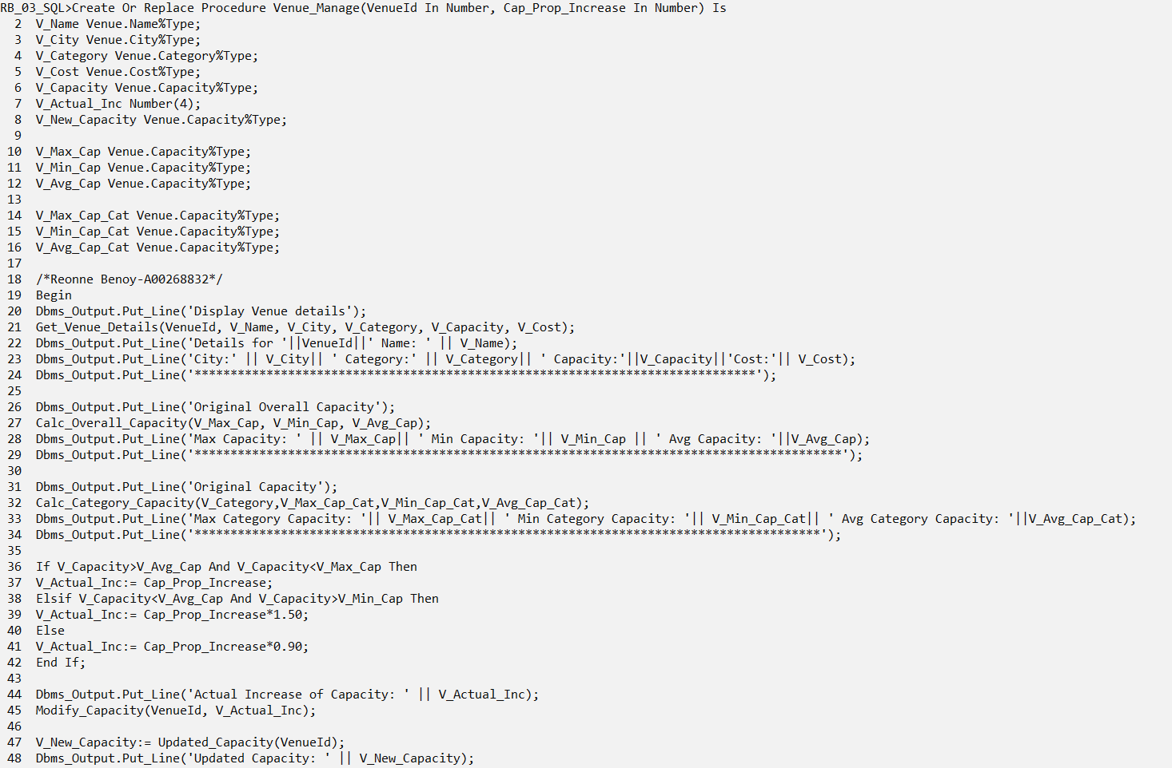

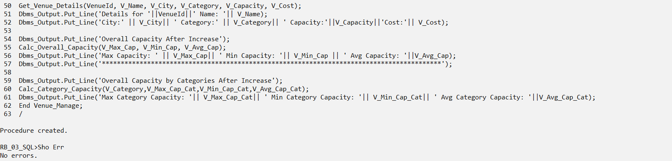

Execute Venue_Manage(4,1000);

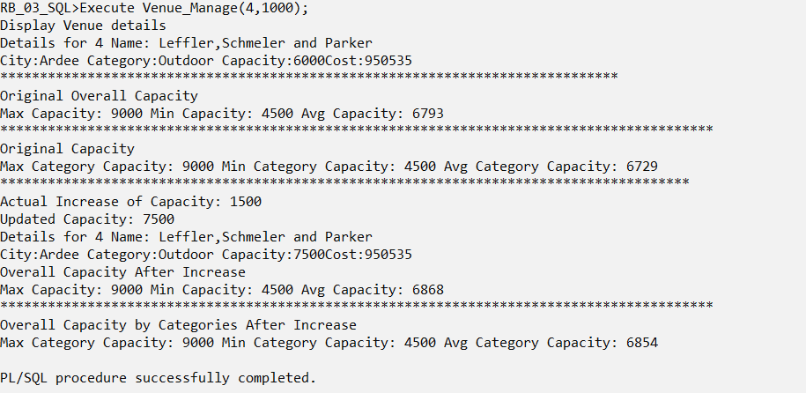

Rollback;

## Stage 3

**Local Procedures and Functions**

Clear Screen

Set Serveroutput On Size 1000000

Create Or Replace Procedure Venue_Manage(VenueId In Number, Cap_Prop_Increase In Number) Is

V_Name Venue.Name%Type;

V_City Venue.City%Type;

V_Category Venue.Category%Type;

V_Cost Venue.Cost%Type;

V_Capacity Venue.Capacity%Type;

V_Actual_Inc Number(4);

V_New_Capacity Venue.Capacity%Type;

V_Max_Cap Venue.Capacity%Type;

V_Min_Cap Venue.Capacity%Type;

V_Avg_Cap Venue.Capacity%Type;

V_Max_Cap_Cat Venue.Capacity%Type;

V_Min_Cap_Cat Venue.Capacity%Type;

V_Avg_Cap_Cat Venue.Capacity%Type;

Procedure Get_Venue_Details(VenueId In Number, V_Name Out Varchar, V_City Out Varchar, V_Category Out Varchar, V_Capacity Out Number, V_Cost Out Number) As

Begin

Select Name,City,Category,Cost,Capacity Into V_Name,V_City,V_Category,V_Cost,V_Capacity

From Venue

Where Venue.Venue_Id = VenueId;

End Get_Venue_Details;

Procedure Calc_Overall_Capacity(V_Max_Cap Out Number, V_Min_Cap Out Number, V_Avg_Cap Out Number) As

Begin

Select Max(Capacity),Min(Capacity),Avg(Capacity) Into V_Max_Cap,V_Min_Cap, V_Avg_Cap

From Venue;

End Calc_Overall_Capacity;

Procedure Calc_Category_Capacity(V_Category In Varchar, V_Max_Cap_Cat Out Number, V_Min_Cap_Cat Out Number, V_Avg_Cap_Cat Out Number) As

Begin

Select Max(Capacity),Min(Capacity),Avg(Capacity) Into V_Max_Cap_Cat, V_Min_Cap_Cat, V_Avg_Cap_Cat

From Venue

Where Venue.Category = V_Category;

End Calc_Category_Capacity;

Procedure Modify_Capacity(VenueId In Number, V_Actual_Inc In Number) As

Begin

Update Venue

Set Capacity=Capacity + V_Actual_Inc

Where Venue.Venue_Id = VenueId;

End Modify_Capacity;

Function Updated_Capacity(VenueId In NUMBER) Return Number Is

V_Updated_Capacity Venue.Capacity%Type;

Begin

Select Capacity Into V_Updated_Capacity

From Venue

Where Venue.Venue_Id = VenueId;

Return V_Updated_Capacity;

End Updated_Capacity;

/*Reonne Benoy-A00268832*/

Begin

Dbms_Output.Put_Line('Display Venue details');

Get_Venue_Details(VenueId, V_Name, V_City, V_Category, V_Capacity, V_Cost);

Dbms_Output.Put_Line('Details for '||VenueId||' Name: ' || V_Name);

Dbms_Output.Put_Line('City:' || V_City|| ' Category:' || V_Category|| ' Capacity:'||V_Capacity||'Cost:'|| V_Cost);

Dbms_Output.Put_Line('******************************************************************************');

Dbms_Output.Put_Line('Original Overall Capacity');

Calc_Overall_Capacity(V_Max_Cap, V_Min_Cap, V_Avg_Cap);

Dbms_Output.Put_Line('Max Capacity: ' || V_Max_Cap|| ' Min Capacity: '|| V_Min_Cap || ' Avg Capacity: '||V_Avg_Cap);

Dbms_Output.Put_Line('******************************************************************************************');

Dbms_Output.Put_Line('Original Capacity');

Calc_Category_Capacity(V_Category,V_Max_Cap_Cat,V_Min_Cap_Cat,V_Avg_Cap_Cat);

Dbms_Output.Put_Line('Max Category Capacity: '|| V_Max_Cap_Cat|| ' Min Category Capacity: '|| V_Min_Cap_Cat|| ' Avg Category Capacity: '||V_Avg_Cap_Cat);

Dbms_Output.Put_Line('***************************************************************************************');

If V_Capacity>V_Avg_Cap And V_Capacity<V_Max_Cap Then

V_Actual_Inc:= Cap_Prop_Increase;

Elsif V_Capacity<V_Avg_Cap And V_Capacity>V_Min_Cap Then

V_Actual_Inc:= Cap_Prop_Increase*1.50;

Else

V_Actual_Inc:= Cap_Prop_Increase*0.90;

End If;

Dbms_Output.Put_Line('Actual Increase of Capacity: ' || V_Actual_Inc);

Modify_Capacity(VenueId, V_Actual_Inc);

V_New_Capacity:= Updated_Capacity(VenueId);

Dbms_Output.Put_Line('Updated Capacity: ' || V_New_Capacity);

Get_Venue_Details(VenueId, V_Name, V_City, V_Category, V_Capacity, V_Cost);

Dbms_Output.Put_Line('Details for '||VenueId||' Name: '|| V_Name);

Dbms_Output.Put_Line('City:' || V_City|| ' Category:' || V_Category|| ' Capacity:'||V_Capacity||'Cost:'|| V_Cost);

Dbms_Output.Put_Line('Overall Capacity After Increase');

Calc_Overall_Capacity(V_Max_Cap, V_Min_Cap, V_Avg_Cap);

Dbms_Output.Put_Line('Max Capacity: ' || V_Max_Cap|| ' Min Capacity: '|| V_Min_Cap || ' Avg Capacity: '||V_Avg_Cap);

Dbms_Output.Put_Line('******************************************************************************************');

Dbms_Output.Put_Line('Overall Capacity by Categories After Increase');

Calc_Category_Capacity(V_Category,V_Max_Cap_Cat,V_Min_Cap_Cat,V_Avg_Cap_Cat);

Dbms_Output.Put_Line('Max Category Capacity: '|| V_Max_Cap_Cat|| ' Min Category Capacity: '|| V_Min_Cap_Cat|| ' Avg Category Capacity: '||V_Avg_Cap_Cat);

End Venue_Manage;

/

Sho Err

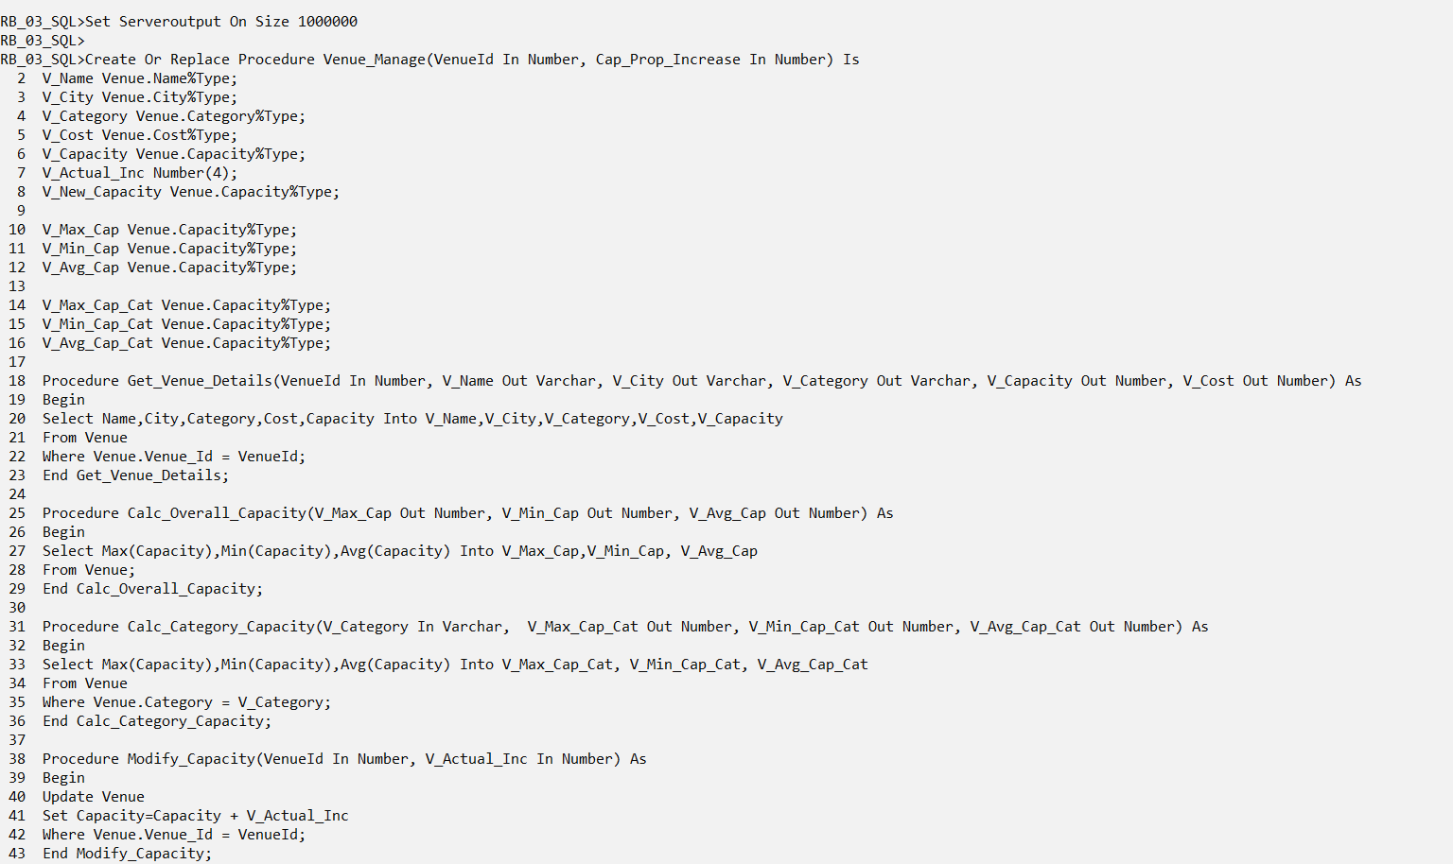

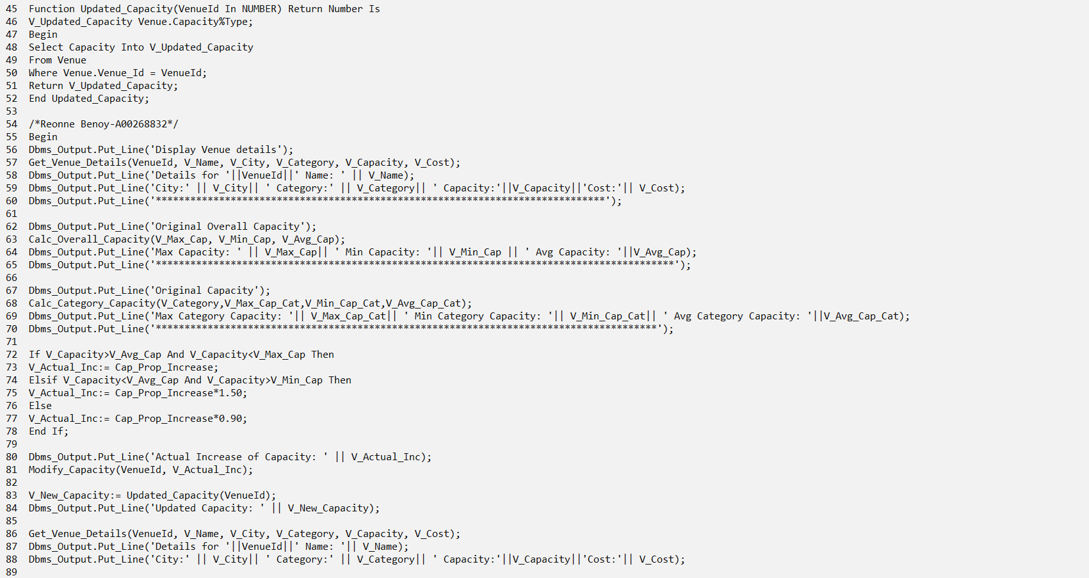

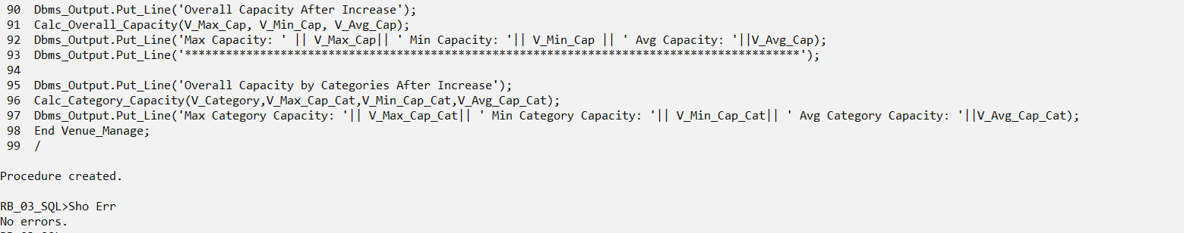

Execute Venue_Manage(4,1000);

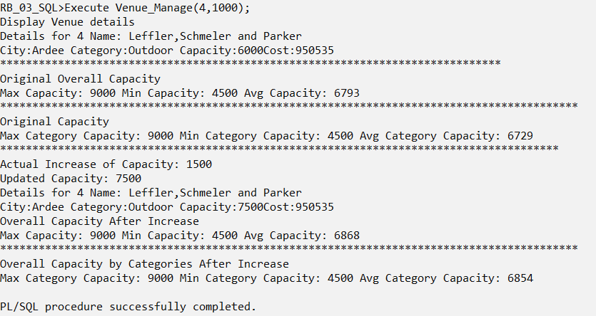

Rollback;

# Youtube Video Link

<https://youtu.be/hf2ZIN7U4J8>